**Internet of Things**

**Project Book**



GÖRKEM ÖZYURT

218MI1034



**Security System With RFID Card**

**CONTENTS**

METARIALS 3

General Information About Metarials 4

1-General Information About Arduino Uno 4

2-General Information About Breadboard. 5

3-General Information About RFID Card. 6

4-General Information About HC-SR501 PIR Motion Detector 7

5-General Information About 10K ohm Resistor. 8

6-General Information About Buzzer. 9

7-General Information Push Button four pin. 10

Circuit Design 11

Arduino Sketch 13

**METARIALS**

* Arduino Uno Card
* Breadboard
* Jumper Wires Pack M/M
* Jumper wires pack M/F
* RFID Card
* PIR (motion) sensor
* Buzzer
* Push Button
* 10k ohm resistor

General Information About Metarials

1-General Information About Arduino Uno

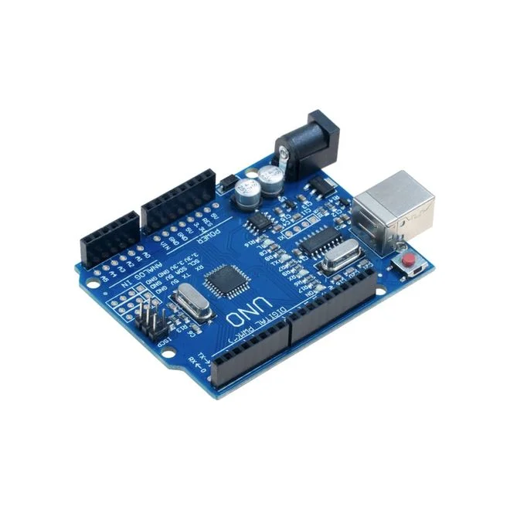

Arduino UNO is a low-cost, flexible, and easy-to-use programmable open-source microcontroller board that can be integrated into a variety of electronic projects. This board can be interfaced with other Arduino boards, Arduino shields, Raspberry Pi boards and can control relays, LEDs, servos, and motors as an output.

2-General Information About Breadboard.

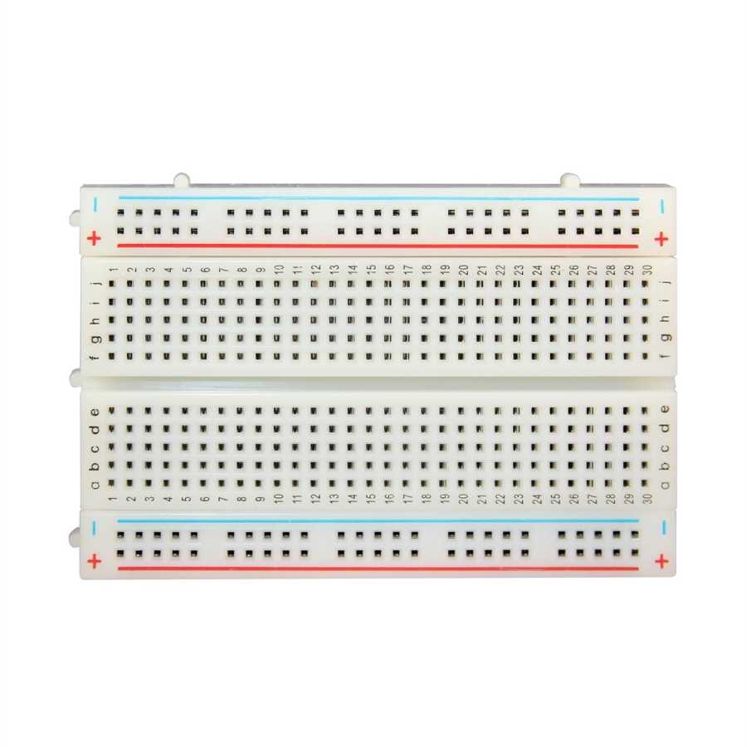

The purpose of the breadboard is to make quick electrical connections between components- like resistors, LEDs, capacitors, etc- so that you can test your circuit before permanently soldering it together.

3-General Information About RFID Card.

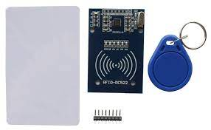

RFID Smart Cards store information on a chip embedded in the smart card. The chip contains an embedded secure microprocessor or equivalent intelligence and internal memory. An antenna is also embedded in the plastic body of the card. Passive RFID tags are powered by the reader and do not have a battery. Active RFID tags are powered by batteries. RFID tags can store a range of information from one serial number to several pages of data. Readers can be mobile so that they can be carried by hand, or they can be mounted on a post or overhead.

4-General Information About HC-SR501 PIR Motion Detector

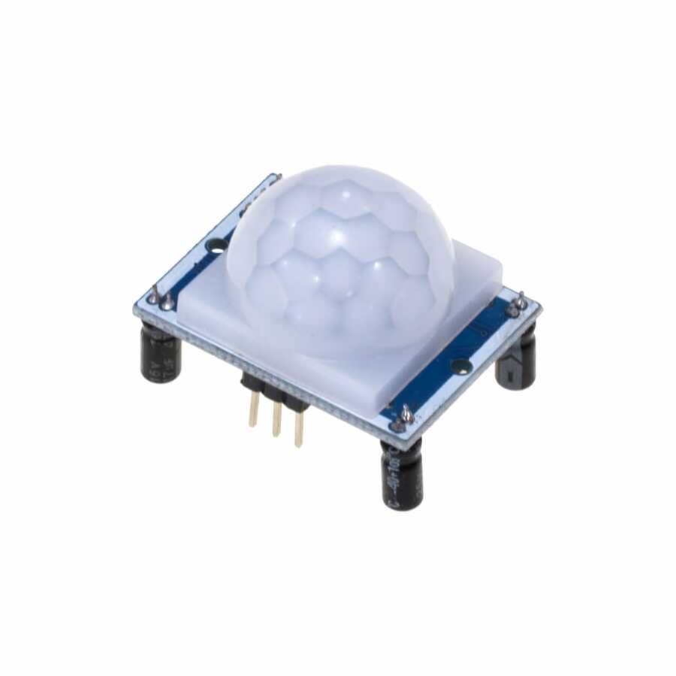

HC-SR501 PIR Sensor detects motion by measuring changes in the infrared (heat) levels emitted by surrounding objects. When motion is detected the PIR sensor outputs a high signal on its output pin. HC-SR501 PIR Sensor has an adjustable delay before firing and adjustable sensitivity.

5-General Information About 10K ohm Resistor.

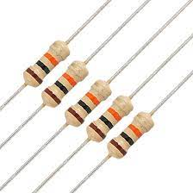

A 10k resistor is a passive resistor but is a great help in controlling the flow of electric current in the circuit. It is called a 10k ohm resistor due to the resistance of 10,000 Ohms. Its recognition is easy with the help of its color band.

6-General Information About Buzzer.

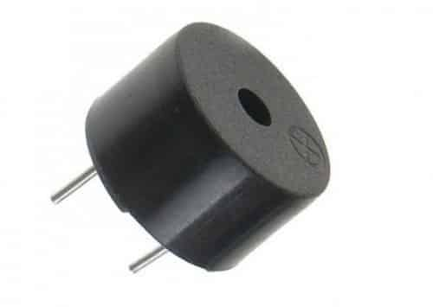

An Arduino Buzzer is basically a beeper. The Arduino buzzer is a device that produces sound when an electric current is passed through it. The Arduino buzzer can be directly connected to the Arduino and produce different tones by giving different frequency electric pulses to the buzzer.

7-General Information Push Button four pin.

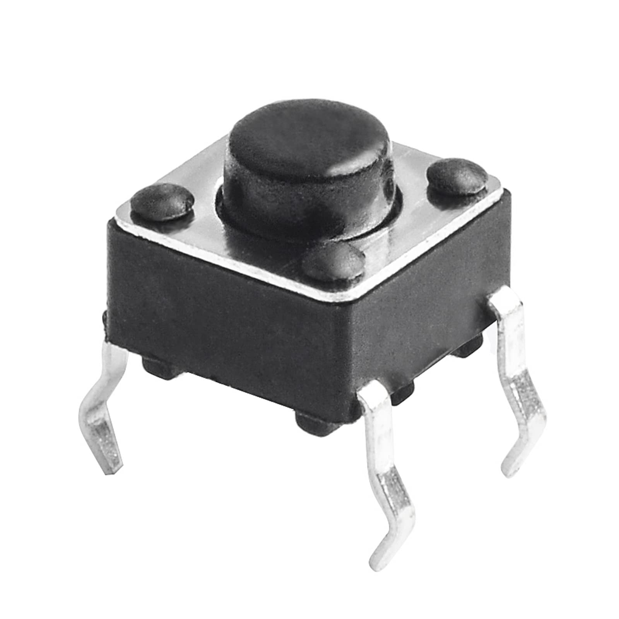

Pushbuttons or switches connect two points in a circuit when you press them. This example the button will start our system.

Circuit Design

Circuit design

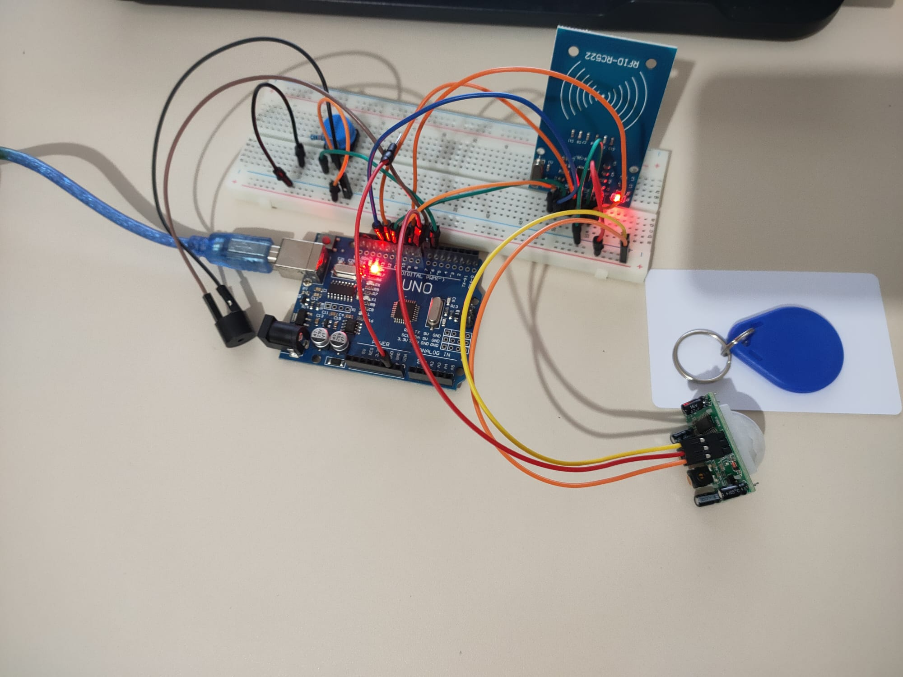

Arduino Sketch

CODES;

#include <SPI.h>

#include <MFRC522.h>

int RST_PIN = 9;

int SS_PIN = 10;

bool hareket = false;

bool aktif = false;

float bekleme1 = 10;

int bekleme2 = 10;

float sayac = bekleme2;

MFRC522 rfid(SS_PIN, RST_PIN);

byte ID[4] = {

  80,

  175,

  255,

  211

};

void setup() {

  Serial.begin(9600);

  SPI.begin();

  rfid.PCD_Init();

  pinMode(8, INPUT);

  pinMode(7, OUTPUT);

  pinMode(6, INPUT);

}

void loop() {

  if (digitalRead(6) == HIGH) {

    digitalWrite(7, HIGH);

    delay(100);

    digitalWrite(7, LOW);

    delay(bekleme1 * 1000);

    aktif = true;

  }

  if (digitalRead(8) == HIGH && aktif == true) {

    digitalWrite(7, HIGH);

    delay(100);

    digitalWrite(7, LOW);

    hareket = true;

    while (hareket) {

      if (sayac <= 0) {

        digitalWrite(7, HIGH);

      } else {

        delay(100);

        sayac -= 0.1;

      }

      Serial.println(sayac);

      if (rfid.PICC_IsNewCardPresent()) {

        if (rfid.PICC_ReadCardSerial()) {

          if (rfid.uid.uidByte[0] == ID[0] &&

            rfid.uid.uidByte[1] == ID[1] &&

            rfid.uid.uidByte[2] == ID[2] &&

            rfid.uid.uidByte[3] == ID[3]) {

            hareket = false;

            aktif = false;

            digitalWrite(7, HIGH);

            delay(100);

            digitalWrite(7, LOW);

          }

        }

      }

      rfid.PICC_HaltA();

    }

    digitalWrite(7, LOW);

    sayac = bekleme2;

  }

}

**Görkem Özyurt**

**218MI1034**